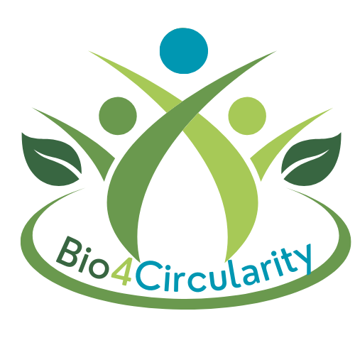
Bio4Circularity Network

Consent to the processing of personal data
with attached privacy policy

I, _______________________________________________________ _________
(first name and surname) hereby consent to the processing of the following personal data:

- First name, last name, title, affiliation, address, email, pictures, interactive elements

in connection with:
The Bio4Circularity Network and its communication and dissemination activities

in accordance with the following privacy policy.
Note on Revocation
You have the right to revoke this declaration of consent at any time without giving reasons with effect for the future. The legality of the data processing carried out based on the consent until the revocation is not affected by this. If consent is not withdrawn, it will remain valid for 10 years.

Please send your cancellation in text form to:

Hamburg University of Applied Sciences, Research and Transfer Centre Sustainable Development and Climate Change Management, Att. Jelena Barbir, Director of the Bio4Circularity Network, Ulmenliet 20, 21033 Hamburg, Germany, E-Mail: Jelena.barbir@haw-hamburg.de

Consent is voluntary. If you do not give your consent or revoke it, you will not suffer any disadvantages.

__________________________ ________________________
Place, date Signature

Data Privacy Policy
General information
We take the protection of your personal data very seriously. This includes informing you about what data we process from you, i.e. when, how and for what purpose. In this data protection declaration, we inform you in accordance with Art. 13 GDPR about data processing in connection with:
Bio4Circularity Networking, Project Proposals, Events, Communication and Dissemination activities

Responsible body and contact
Responsible for the processing of your personal data is
Hamburg University of Applied Sciences, Research and Transfer Centre Sustainable Development and Climate Change Management, Att. Jelena Barbir, Director of Bio4Circularity Network, Ulmenliet 20, 21033 Hamburg, Germany, E-Mail: Jelena.barbir@haw-hamburg.de
Controller of the personal data (responsible entity) in the sense of the General Data Protection Regulation (GDPR) and other national data protection laws of the EU member states as well as other data protection regulations:
Hochschule für Angewandte Wissenschaften (HAW Hamburg)
Berliner Tor 5, 20099 Hamburg, Germany
T: +49.40.42875-0 / F: +49.40.42875-9149, E-Mail: datenschutz (at) haw-hamburg (dot) de
Data protection officer
datenschutz nord GmbH, Konsul-Smidt-Straße 88, 28217 Bremen, Germany
www.datenschutz-nord-gruppe.de / E-Mail: office[at]datenschutz-nord.de

Purposes and legal bases of processing
Your data is processed for network management, in particular internal project communications, establishing contact to external stakeholders needed for pursuing project tasks and networking, monitoring and evaluation tasks and reporting of work progress and capacity-building impact towards the EU. The processing is carried out on the basis of Art. 6 para. 1 letter a GDPR.

Recipients of the personal data
Personal data may be passed on to third parties in the frame of Bio4Circularity communication and dissemination action (e.g. for publication on social media):
Your personal data may be used on our online presence.

Note on publications on the Internet
When publishing on the Internet (on websites, social media platforms, etc.), personal data (including photos/videos) can be accessed and stored worldwide. The data can therefore be found via search engines. It cannot be ruled out that third parties may link the data with other personal data available on the internet and thus create a personality profile, change the data or use it for other purposes.

Duration of storage of personal data
We do not store your personal data for longer than is necessary for the specified purpose of processing.

Rights of data subjects
According to the General Data Protection Regulation, you have the following rights:

- If your personal data is processed, you have the right to obtain information about the personal data stored about you (Art. 15 GDPR).
- If incorrect personal data is processed, you have the right to rectification (Art. 16 GDPR).
- If the legal requirements are met, you can request the deletion or restriction of the processing and object to the processing (Art. 17, 18 and 21 GDPR).
- If you have consented to the data processing or a contract for data processing exists and the data processing is carried out using automated procedures, you may have a right to data portability (Art. 20 GDPR).

If you make use of your above-mentioned rights, the public authority will check whether the legal requirements for this are met. You also have the right to lodge a complaint with the Hamburg Data Protection Commissioner.

Other information about our privacy policy
We reserve the right to amend this privacy policy from time to time to ensure that it always complies with current legal requirements or to implement changes to our services in the privacy policy, e.g. when introducing new functions and services. The new privacy policy will then apply to future use.

